**SMART WATER MANAGEMNET**

**Sensors and Data Collection**

Utilize sensors across the water infrastructure to gather data in real time. This can contain flow meters, pressure sensors, water quality monitors, and more.

Utilize IoT-enabled devices to keep track of water usage across the system.

**Connectivity**

**To communicate data from sensors to a central system, make sure the connectivity is strong. Wi-Fi, cellular networks, and LPWAN (Low Power Wide Area Network) for rural locations are examples of common communication technologies.**

**Data Analytics and Processing**

**Apply data analytics to the gathered data processing. To obtain insight into water consumption, potential leaks, or contamination, identify patterns, anomalies, and trends.**

**To foresee upcoming problems, use machine learning algorithms for predictive analytics.**

**Centralized Control System**

**Create a centralized management system that can oversee the complete water distribution system. Remote access to this system is required for real-time monitoring.**

**Leak Detection and Management**

**Utilize algorithms to find water distribution system leaks. Rapid detection and action can greatly reduce water loss and stop damage.**

**Monitoring Water Quality**

**Include sensors to track pH, turbidity, and other aspects of chemical composition in water quality. This aids in locating contaminants and assuring compliance with water quality standards.**

**User Participation and Feedback**

**Create a user interface to engage end consumers, such as a mobile app or web portal. Give them information about their water use habits and advice on how to conserve water.**

**Smart controls and automation**

**Utilize automation to regulate water pressure and flow based on demand. As a result, the distribution system is improved and energy use is decreased.**

**Efficiency in Energy**

**Investigate renewable energy sources to power IoT devices and lessen environmental impact**

**Project Description**

Utilizing a variety of IoT technologies to promote transparency and ensure more prudent and sustainable use of these water resources, smart water management is the planning, development, distribution, and management of the use of water resources.

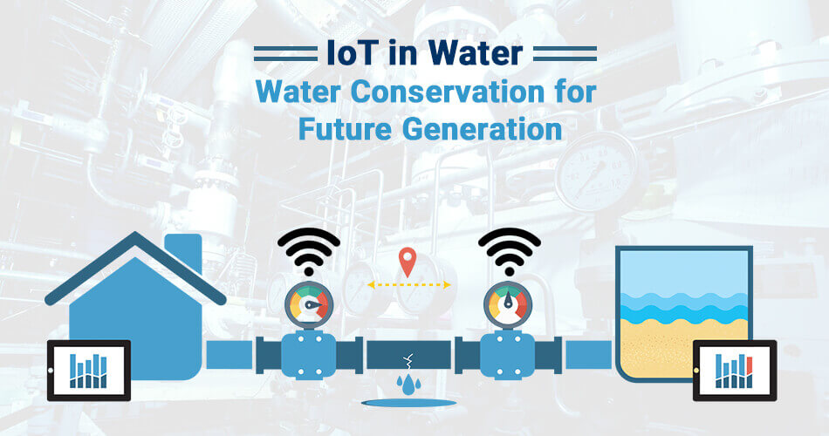

**IOT Implementation**

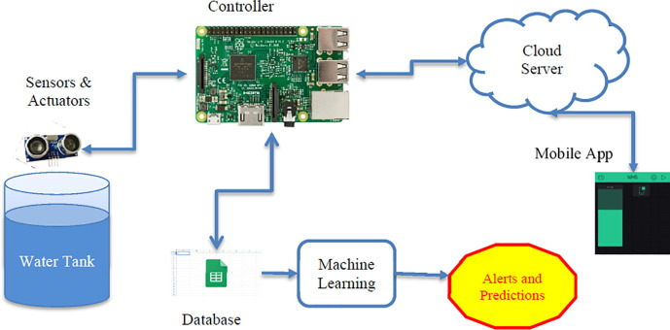

An IoT smart water meter keeps tabs on the quantity, quality, and pressure of water used in a building or company. You can monitor the water flow through the entire plant and via the distribution routes by using an IoT smart water sensor. assisting in leak detection to cut down on water waste.

**Methodology**

Water turbidity, PH, and temperature are continuously monitored by an autonomous system controlled by a single chip microprocessor. The data are collected, processed, and analyzed on a single chip. Using an IOT environment, the data will be transmitted to a monitoring center while simultaneously alerting the general public.

**Circuit Diagram**

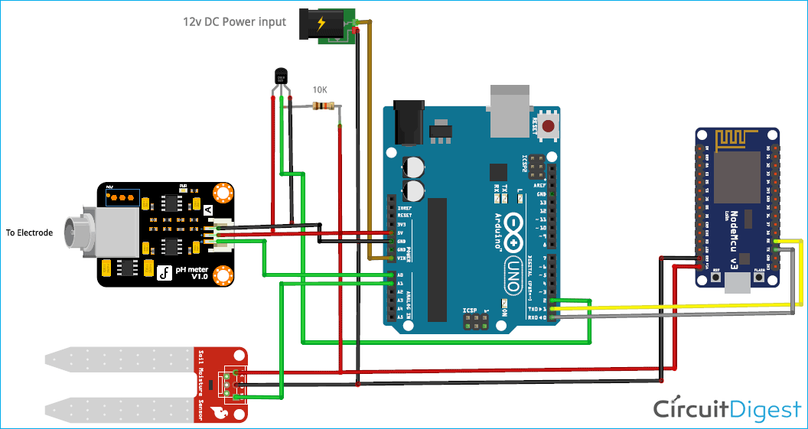

**Coding**

from flask import Flask, render_template, request, jsonify

from flask_sqlalchemy import SQLAlchemy

from datetime import datetime

app = Flask(__name__)

app.config['SQLALCHEMY_DATABASE_URI'] = 'sqlite:///water_usage.db'

db = SQLAlchemy(app)

class WaterUsage(db.Model):

id = db.Column(db.Integer, primary_key=True)

timestamp = db.Column(db.DateTime, default=datetime.utcnow)

amount = db.Column(db.Float)

db.create_all()

def receive_water_data():

data = request.get_json()

if 'amount' in data:

new_water_usage = WaterUsage(amount=data['amount'])

db.session.add(new_water_usage)

db.session.commit()

return jsonify({"status": "success"})

else:

return jsonify({"status": "error", "message": "Invalid data format"}), 400

def get_water_data():

water_data = WaterUsage.query.all()

data = [{"timestamp": entry.timestamp, "amount": entry.amount} for entry in water_data]

return jsonify(data)

def home():

return render_template('index.html')

if __name__ == '__main__':

app.run(debug=True)

**Working Principle of Prototype**

The intelligent controller, which connects to sensors, gathers signals, converts them to digital form, analyses the data, applies algorithms, and then displays the user's water quality data on an HMI or display before sending it to the cloud, is the brains of STREAM.

**Conclusion**

The proposed design, according to this system, becomes more autonomous with quick data transmission thanks to IOT. The fundamental benefit of IOT is that data may be transferred even when clients are not connected to the node network, and they can view the data that has already been delivered.

Water tank overflow can be reduced using smart water management, which can also provide real-time water usage in liters per hour. This system is reasonably priced. As a result, water may be used more effectively. Consequently, it decreases water waste. Using the outcomes of this project, this project can be improved even more. To determine the quality of the water in the tank, a turbidity sensor is installed.